Vu_Kien_Homework 6

**Problem 1:**

1. Mean _ Bayesian R2 = -0.2201 with 95% credible set [ -2.348, 0.597]

Estimators of missing data: Mean_X[5] = 85.95 with 95% credible set [2.966, 192.5]

Mean Y[8] = 104.4 with 95% credible set [99.73, 109.4]

95% credible set of the slope B[1] = [-0.07207, 0.06339]. The set does contain 0, which means in this linear regression model, time may not be relevant in predicting temperature.

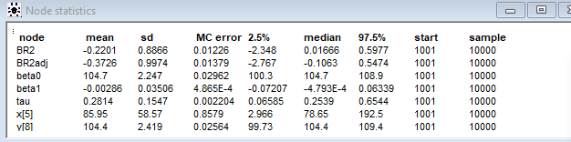**b)**

Mean_ Bayesian R2 = 0.7081 with 95% credible set [-0.05344, 0.9318]

Mean_X[5] = 61.85 with 95% credible set [30.06, 98.12]

Mean_Y[8] = 104.5 with 95% credible set [102.2, 106.7]

Mean B[0] = 96.49 with 95% credible set =[91.56, 103.0]

Mean B[1] = 0.3611 with 95% credible set =[0.1025, 0.5536]

Mean B[2] = -0.003391 with 95% credible set =[-0.005089, -0.001153]

The 95% credible set of parameters does not contain 0, which means all of predictors used in this regression modelling are relevant in predicting temperature.

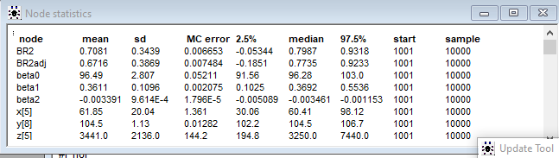

**Problem 2:**

1. 90% Credible Set for Mu1-Mu0 = [1.548, 42.88] with mean = 19.71. Yes, they are all positive.
2. Posterior Probability of mu1 > mu2 is 93.7%
3. Chemotherapy treatment is statistically significant in treating bladder cancer, helps prolong the lifetime and delay cancer recurrence.

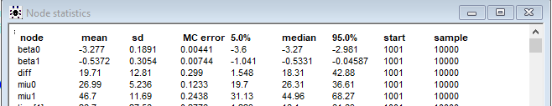

Problem 1a and 1b: Models

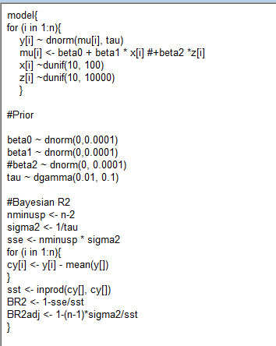

Problem 2: Model

